* STATES OF INDIA

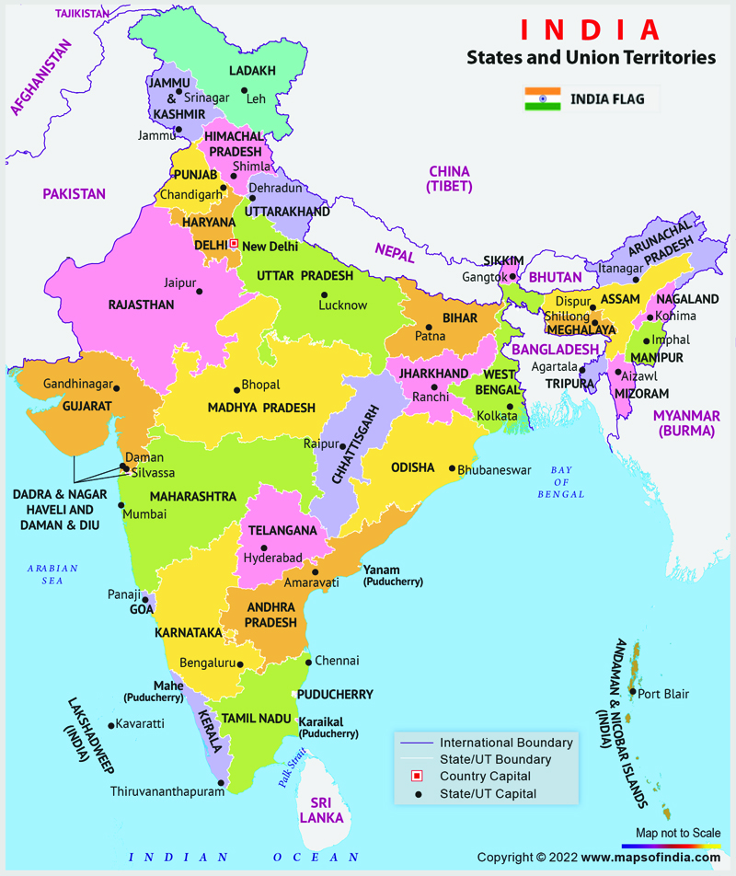

|  |  |
| --- | --- |
| GEOGRAPHY OF INDIA |  |
| Deccan Plateau in India States, Location and Maps |  |

|  |  |
| --- | --- |
| SOIL IN INDIA |  |
| Types of soils in India- Alluvial soil, Black soil, Red soil, etc. |  |